USING SUB QURIES TO SOLVE QURIES

1.Create a report that display EMPNO, ENAME, DEPTNO of employees who work with that Employee.(Nested Sub Query).

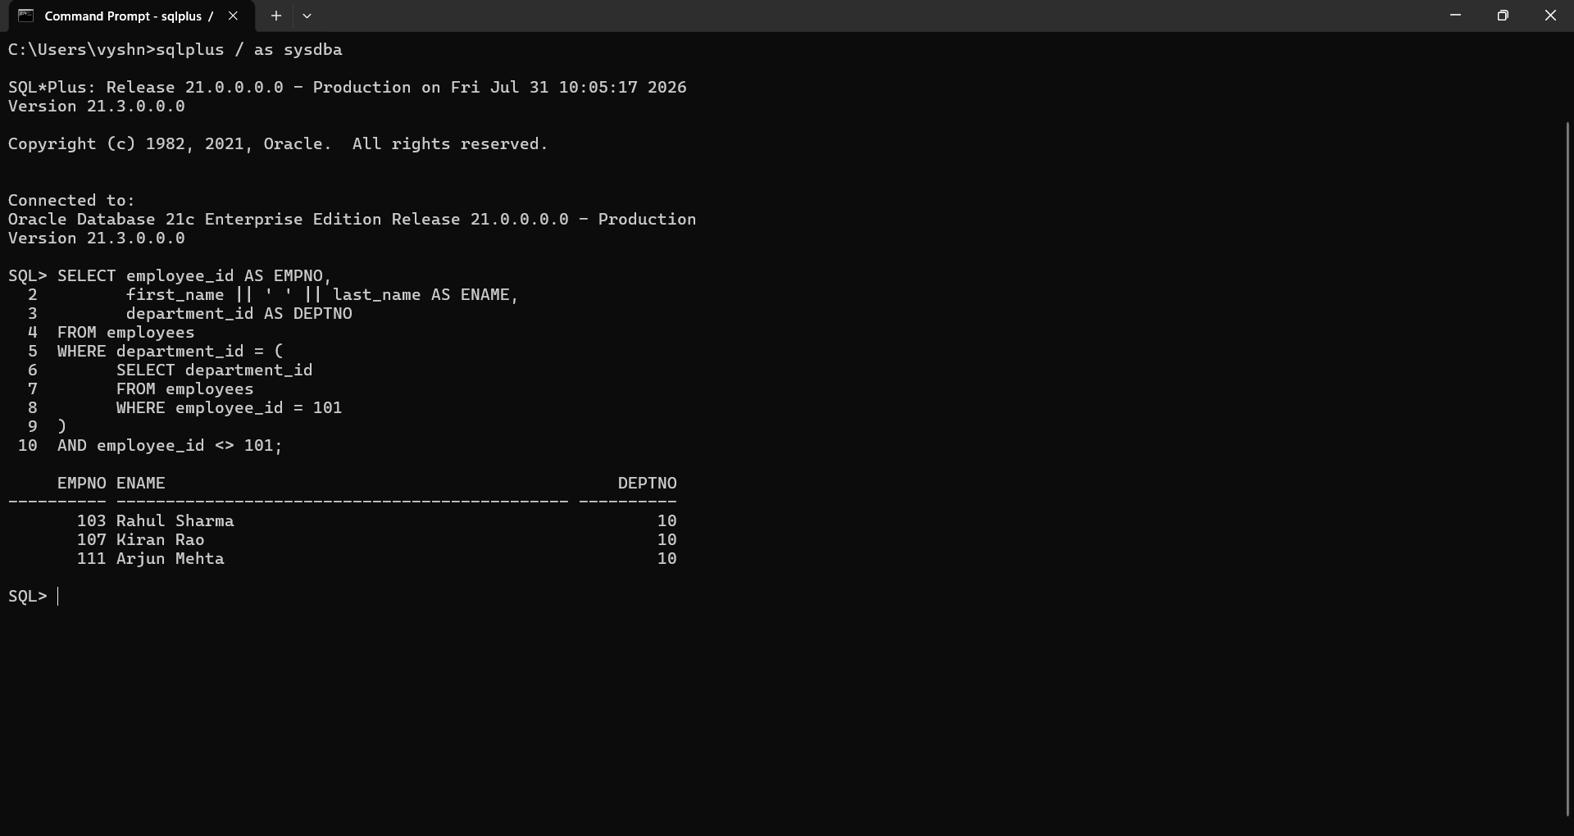

2.Display the employees who earn more than the avg salary of EMP table.(Nested Sub Query).
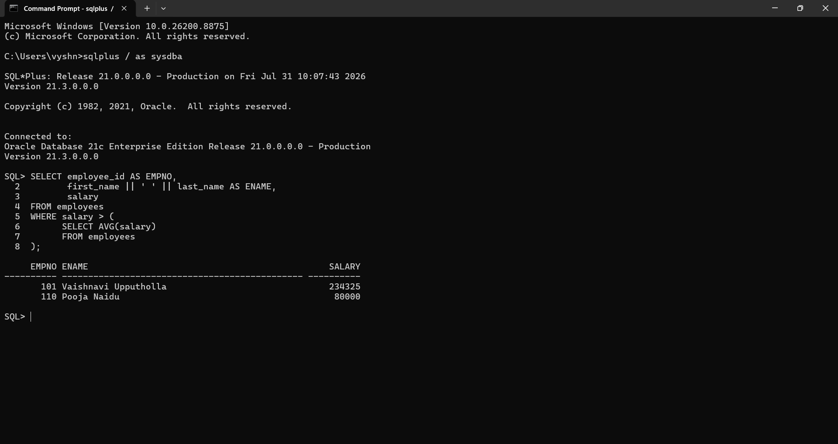

3.Display the ENAME,JOB, who are Managers(Use Exists Operator).
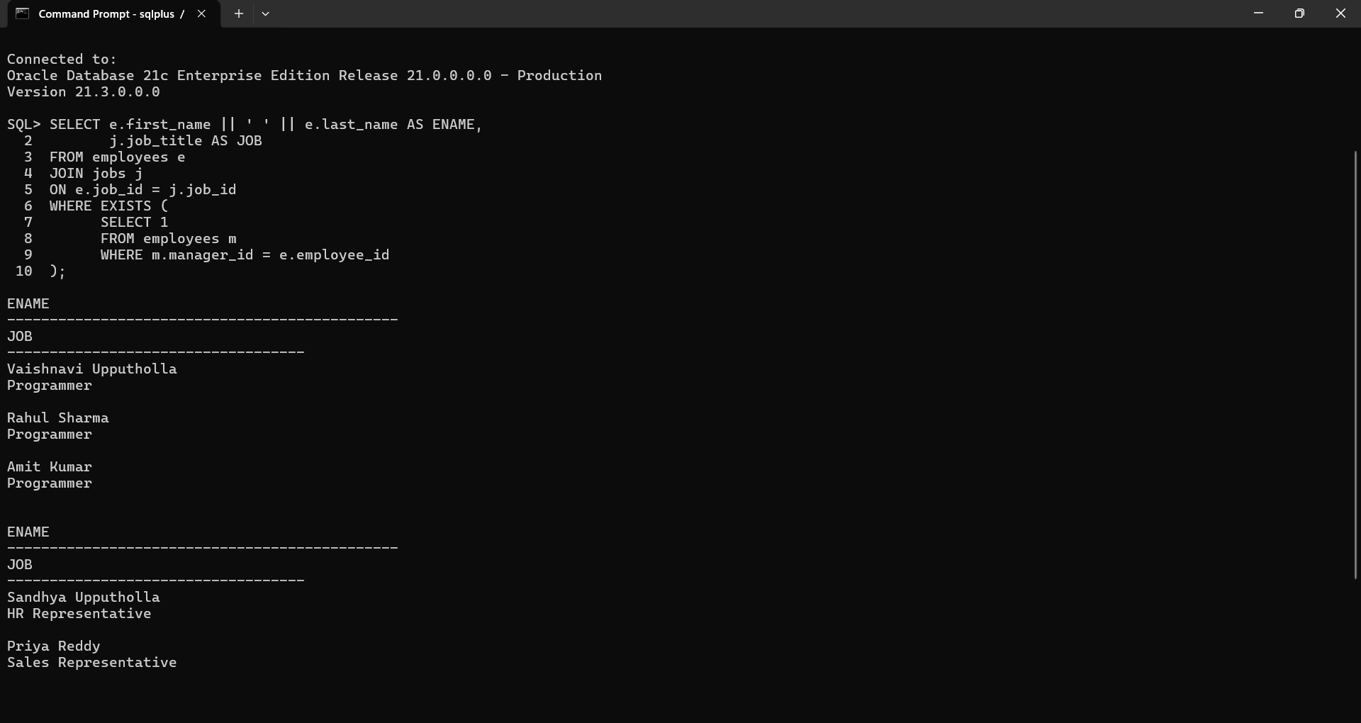

4.Display the employees who earn less than least salary of DEPTNO 10. (Use ALL operator).
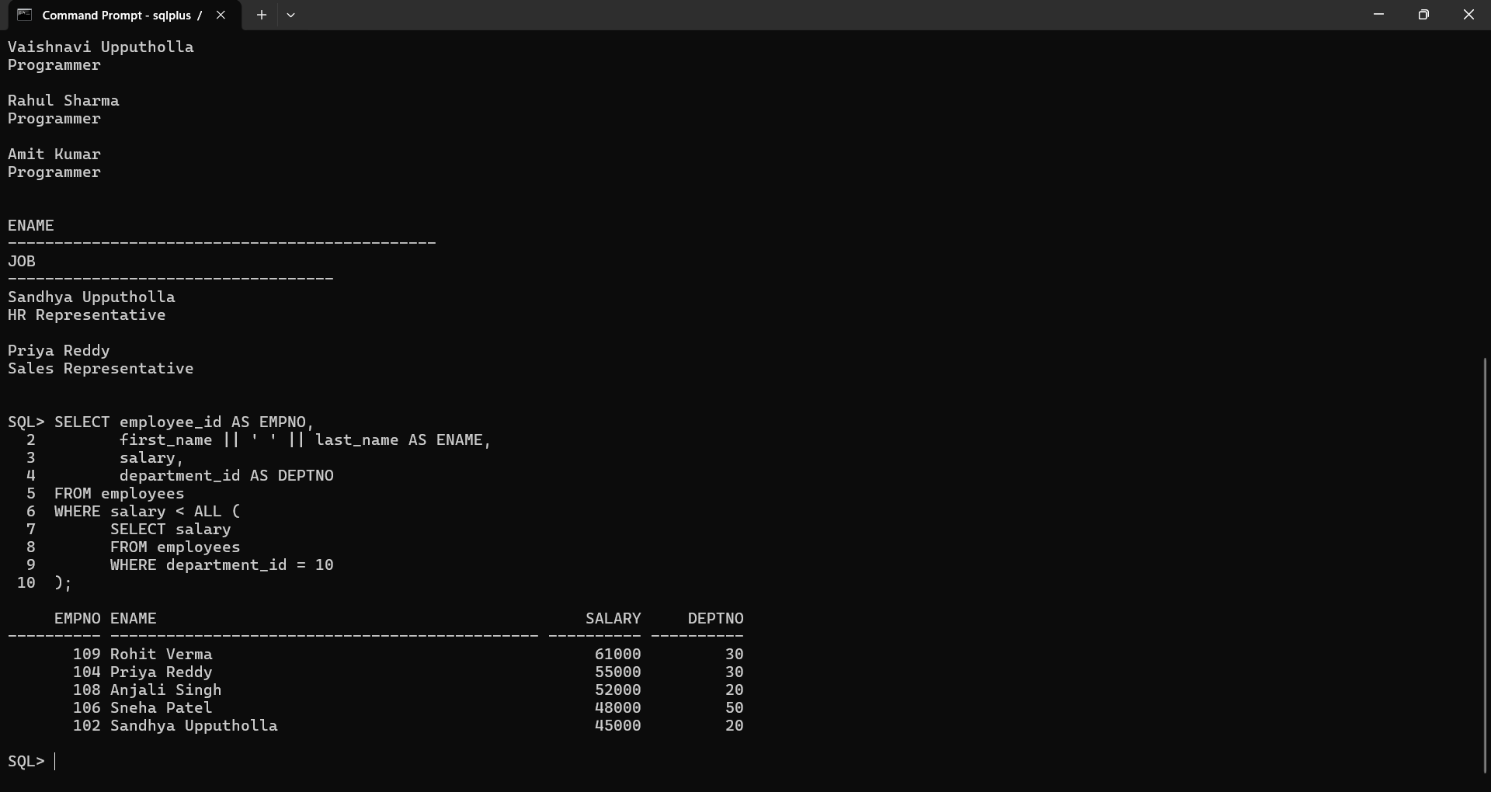

5.Display the employees who have the same DEPTNO and MGR of a given employee, excluding that employee.(Use Nested Sub Query).
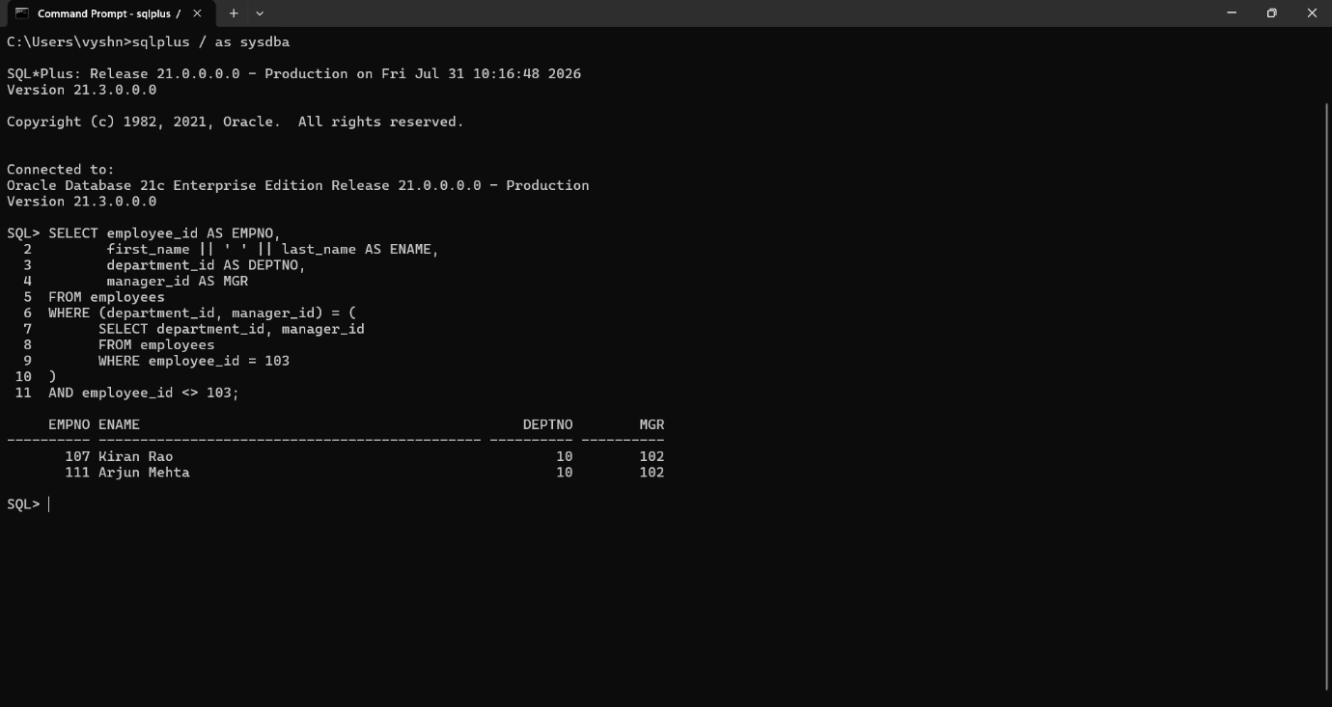

6.write a query that displays the employee number and name of all employees who work in a department with any employee whose name contains a R.
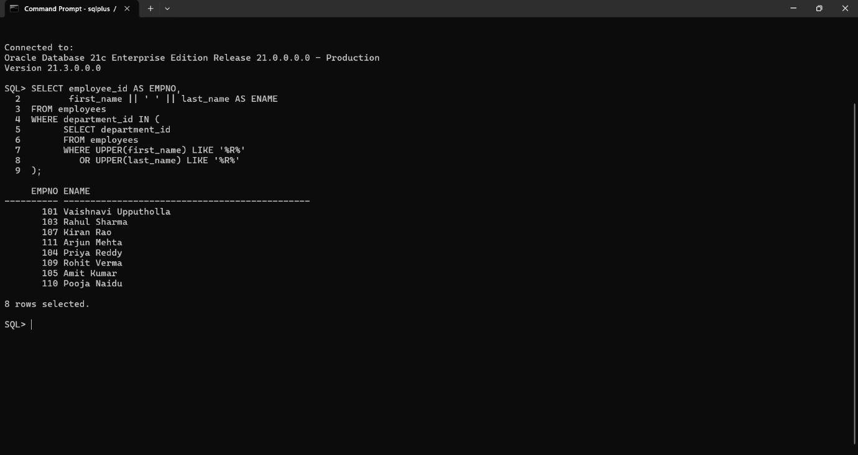

7.The HR department needs a report that displays the ename, deptno, job of all employees whose work in NEW YORK. (Nest Sub Query)
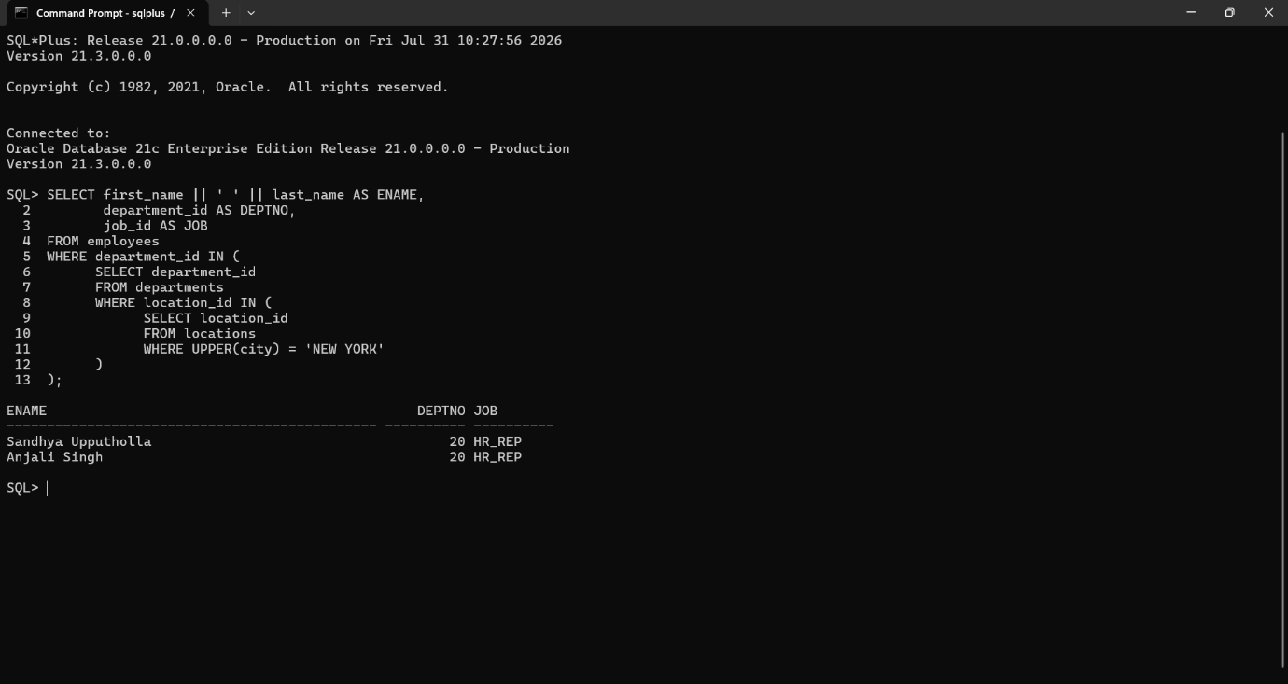

8.Modify the query so that the user is prompted for a LOC.
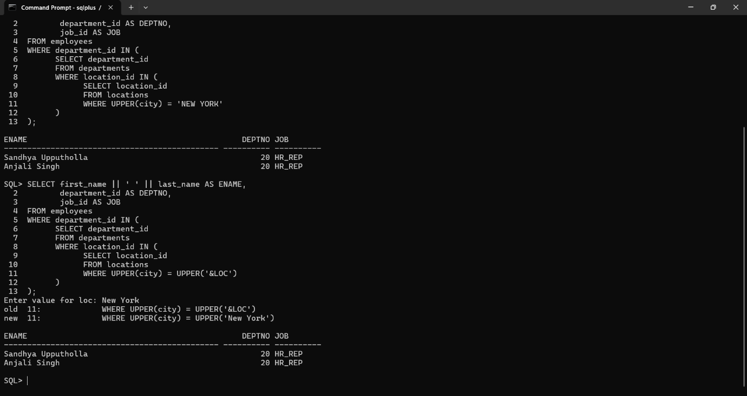

9.Create a report for HR that displays the name and salary of every employee who report to King.(Nest Sub Query).
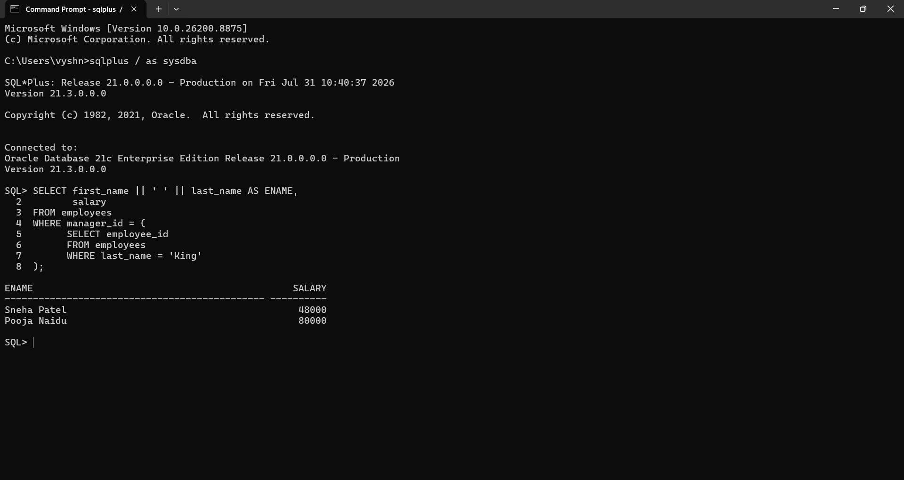

10.Write a query to display all the employees working with JAMES.
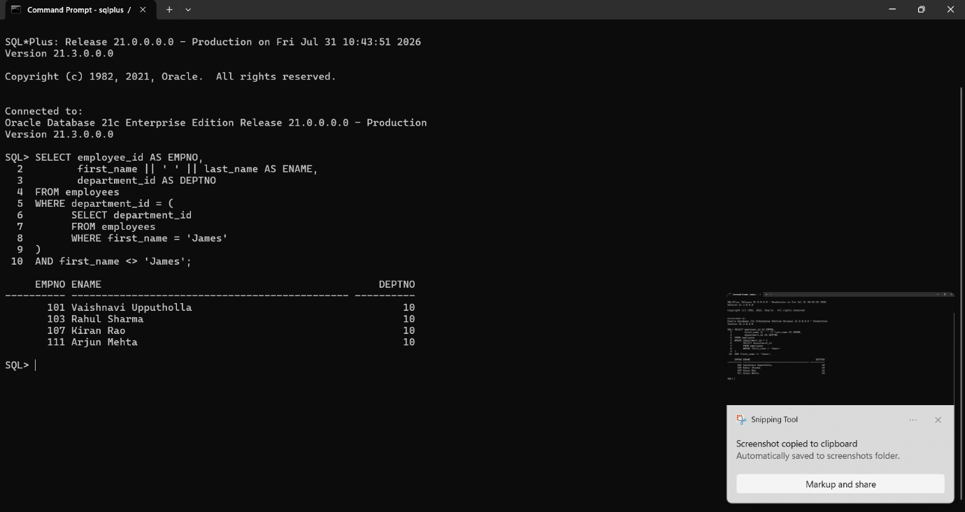

11. Display all the employees who earn less than average salaries of their respective departments. (Correlated Sub Queries).
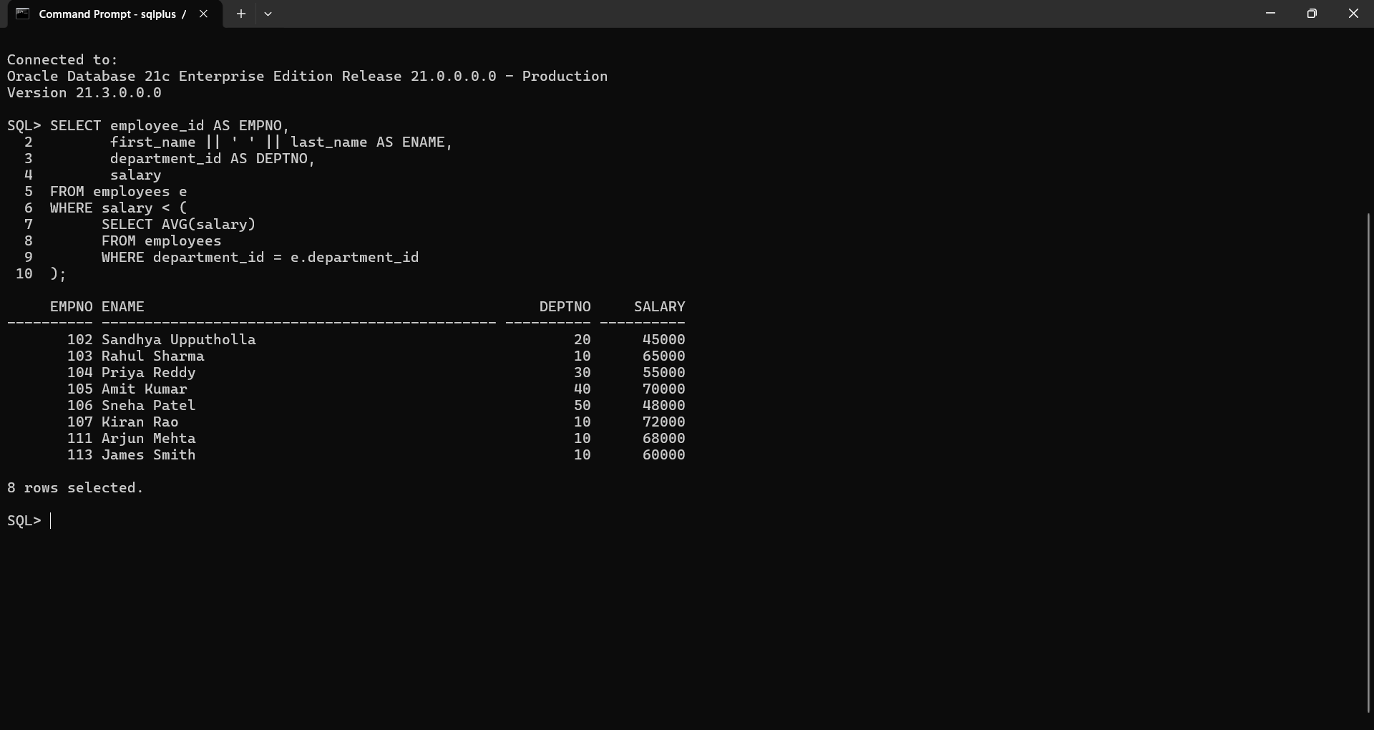

12.Write a query to display the LOC and average salary of Each location. (Scalar Sub query)
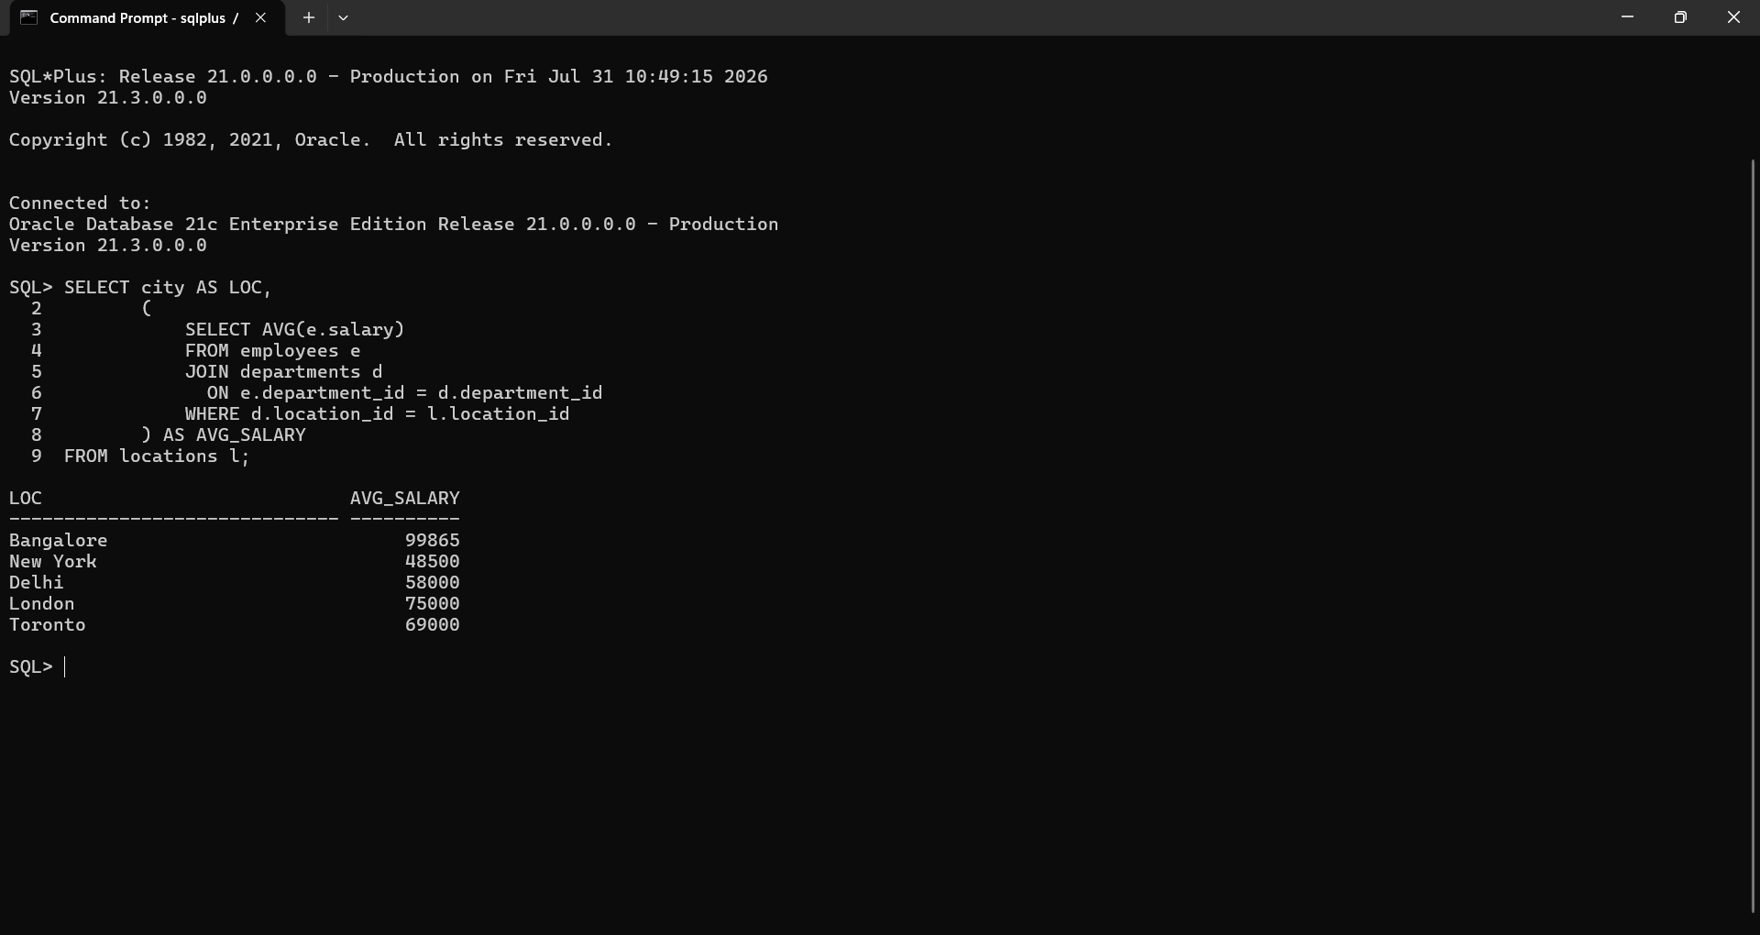

13.Write a query to display the least N salaries. Use In-Line Views.
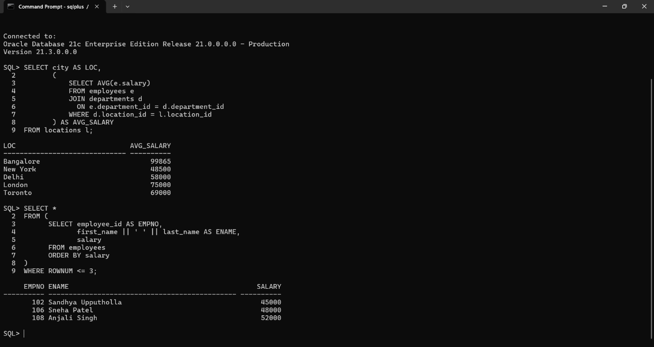

14.Display the Last N rows from the employees table(Use Correlated Sub Queries).
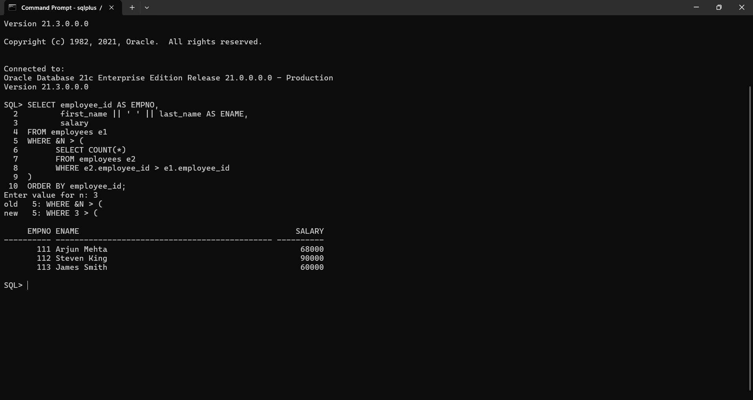

15.Display the employees from employees table and sort only employees working in DALLAS. (Scalar Sub Query)
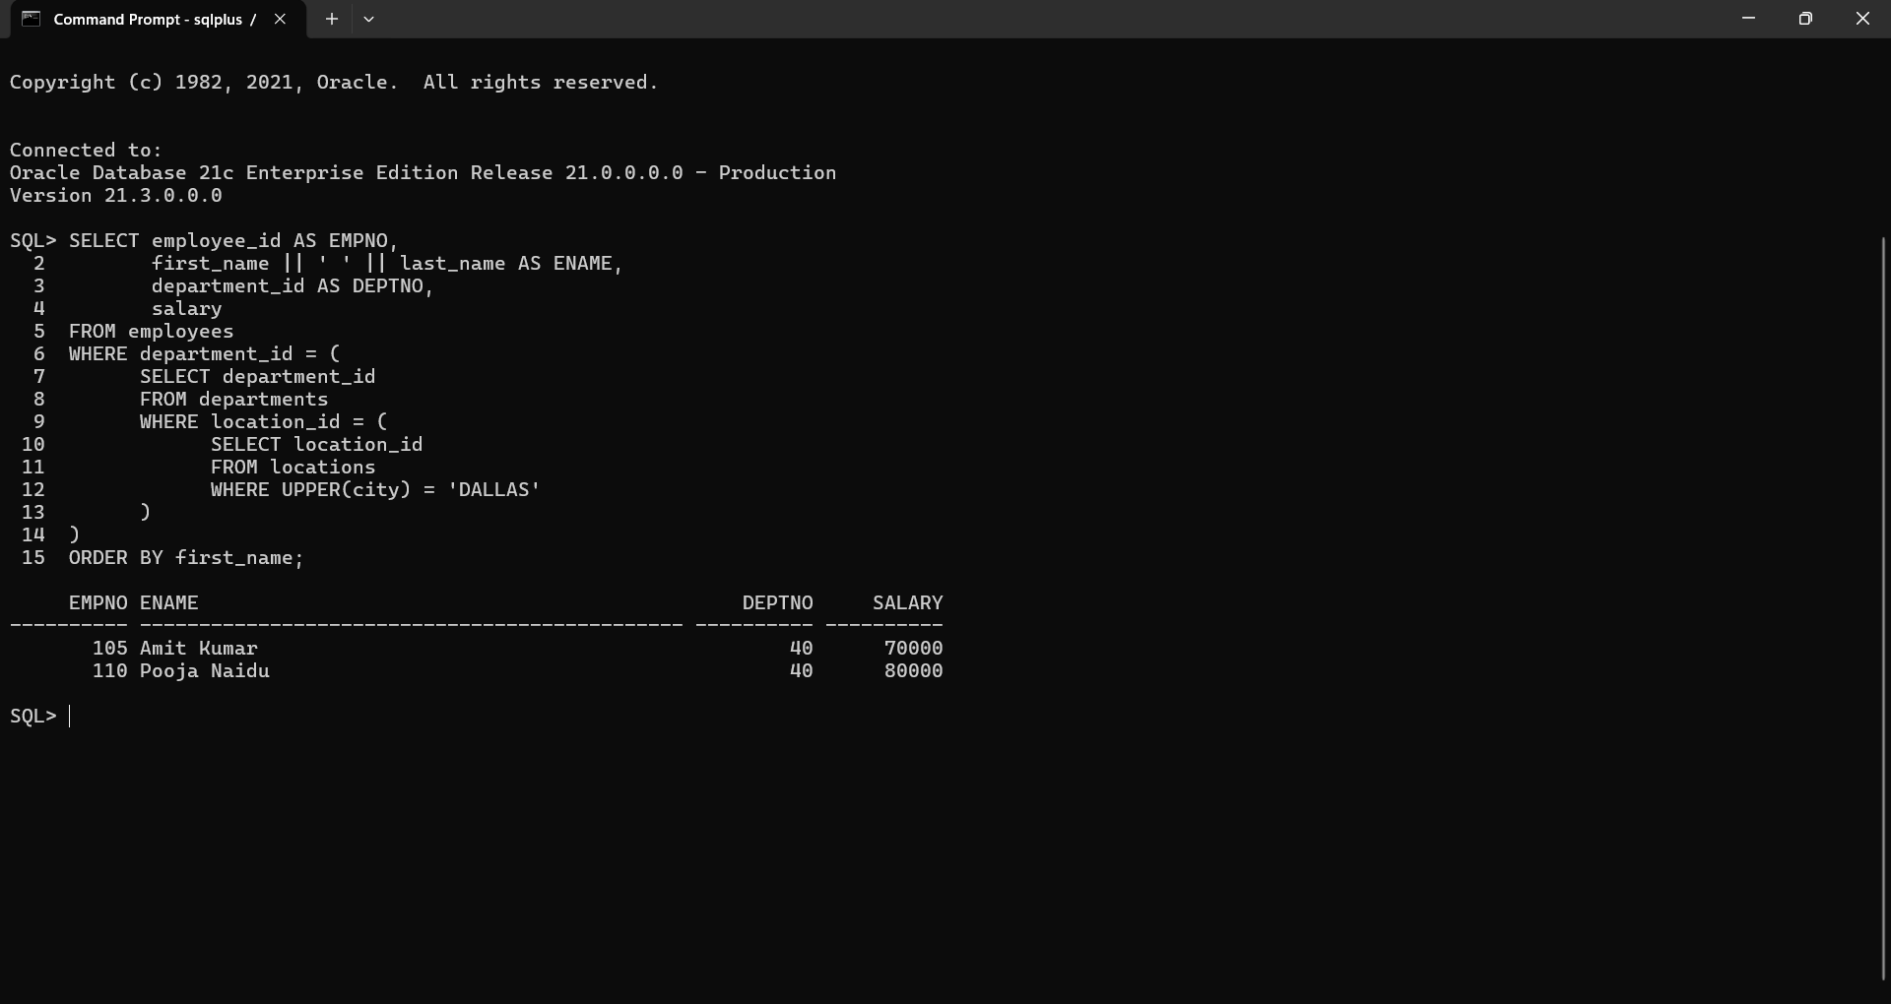

16.Display the employees who earn a salary less than avgsal of their respective department. Also display the avgsal.(Use Inline Views)
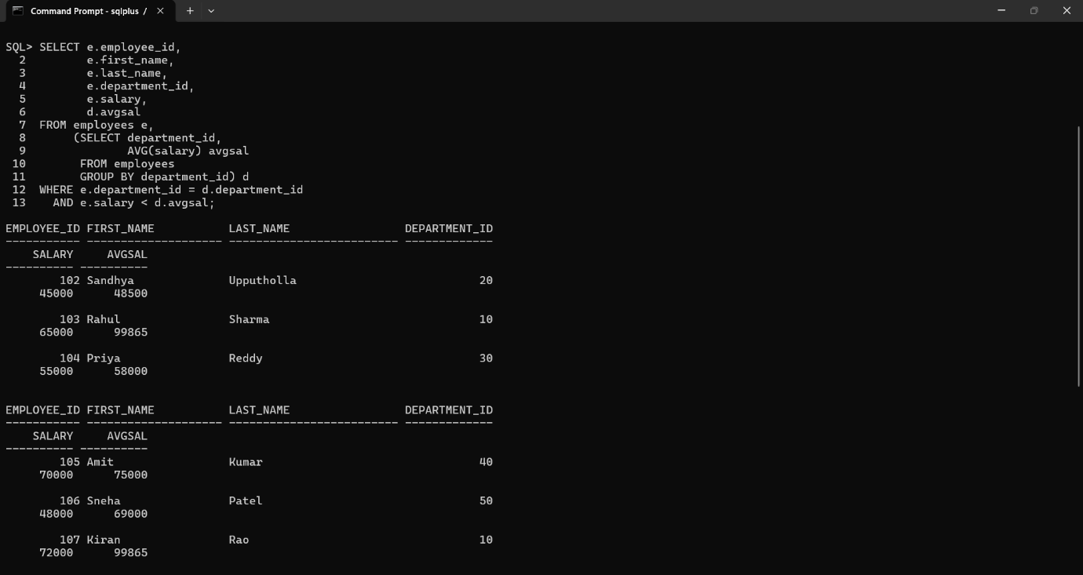
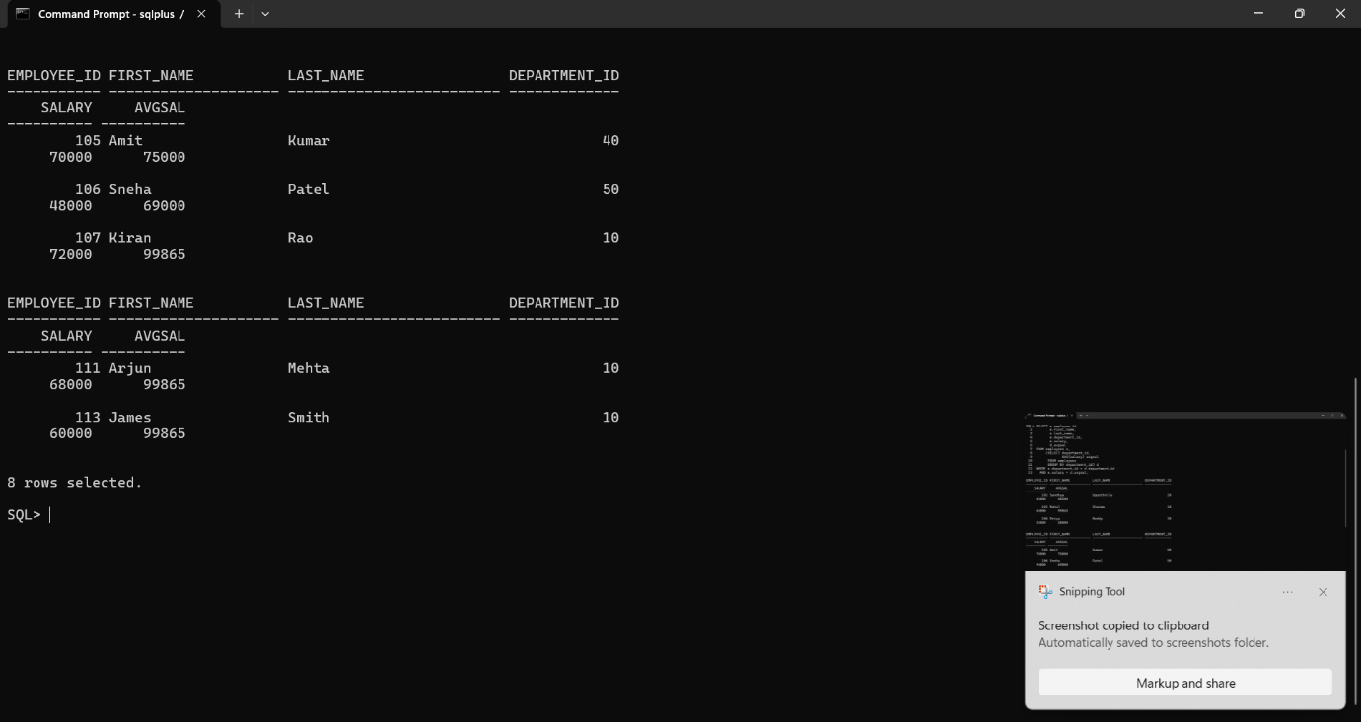

17.Write a query that display the LOC of those DEPTS that have a sum of sal less than the avgsal of all the employees in DEPT table. (Use WITH Clause).
